
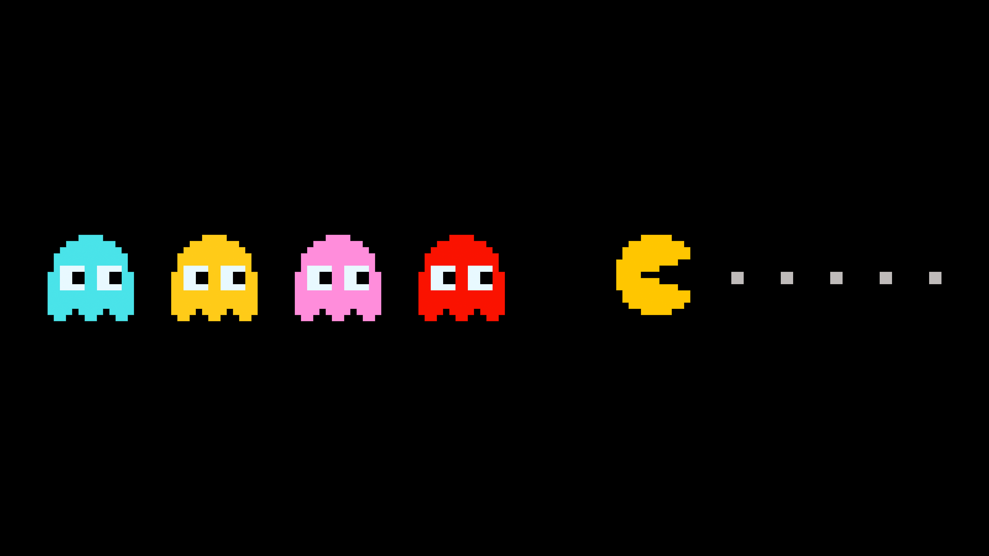
PROJECT PACMAN

:Team Members:

Rahul Chatterjee(1262251741)
Shatakshi Shiravale(1262252433)
Ayushman Tripathi (1262253832)
Srishti Shrivastava(1262250775)
Samruddhi Raskar(1262253382)

:Guided By:
Prof. Shirish Paygude
Dr. Anushri Kulkarni

Submission Date : 19th February 2026


Acknowledgment :


Abstract:
This project presents the development of a simplified Pacman-style game implemented using grid-based maze representation and basic artificial intelligence techniques. The game operates on two difficulty levels: Easy and Hard, with maze sizes of 9×9 and 17×13 respectively. Each maze is stored as a two-dimensional array, where integer values represent different tile types such as empty spaces, walls, pellets, and power-ups.
The movement of the main character (Pacman) and the ghosts is controlled through positional references and interaction with adjacent elements in the maze. Pacman follows continuous directional input until obstructed by walls, while interactions with pellets and power-ups modify the game state dynamically.
Two distinct approaches to ghost movement are implemented. The first approach uses randomized directional movement with probability-based decision-making to simulate unpredictable behaviour. The second approach, used in Hard mode, applies the A* pathfinding algorithm to enable a ghost to actively pursue Pacman by evaluating optimal paths using a cost function.
The project demonstrates the integration of fundamental data structures, control logic, and basic AI techniques in a game environment. It also highlights practical challenges in design decisions, such as handling movement logic and integrating multiple gameplay systems.


Table of Contents:


List of Figures and Tables :


Introduction:


Literature Review:


System Design/Methodology:
Overview of the Approach:

We approached the game of pacman in a way such that it can be implemented using pure C. We used only arrays, pointers and other basic C features to make the project a functional and playable remake of Pacman.

The Maze:

The maze is stored as a 9 x 9 Array in Easy mode and a 17 x 13 Array in Hard mode.

The integer stored in each element of the array represents the tile of the maze

0 - Empty Tile
1 - Tile contains Pellet (represented by •)
2 - Wall (represented by [ ])
3 - Tile contains Power Up (represened by 🍒)

Pacman and the Ghosts

Pacman and the Ghosts are saved as pointers which point to their positions on the maze. Their movement is checked using the values in the neighbouring elements in the maze.

Pacman moves in the direction of the last accepted input until it hits a wall (is in front of an element with the value 2). If the element that pacman moves into contains a pellet (1) or a power up (3), the element is set to 0 and the effects of the pellet/power up are applied

The ghosts use two forms of AI for navigation:

1. Random Movement

The ghosts move in one direction until it faces a wall, in which case it turns around and moves in the opposite direction.

There is a random chance variable which is defined at 10. Everytime the ghost has an opportunity to turn perpendicularly (there is an empty tile perpendicular to its movement), it generates a random number between 0 and 20. If the number is less than the random chance variable, it turns and resets the variable to 10, otherwise it decides not to turn and increases the variable by 1, increasing the chance it turns the next time. This prevents the ghost from constantly moving back and forth.

2. A* Pathfinding Movement

One of the ghosts in hard mode uses the A* pathfinding algorithm to always target pacman, making sure there's an active threat for the player to keep in mind. It uses the formula:

f (x) = g(x) + h(x)

where g(x) is the steps taken to reach the tile and h(x) is the distance from pacman from the tile. It applies this formula to all neighbouring tiles, storing their values in a heap and picks the path with the smallest f(x).
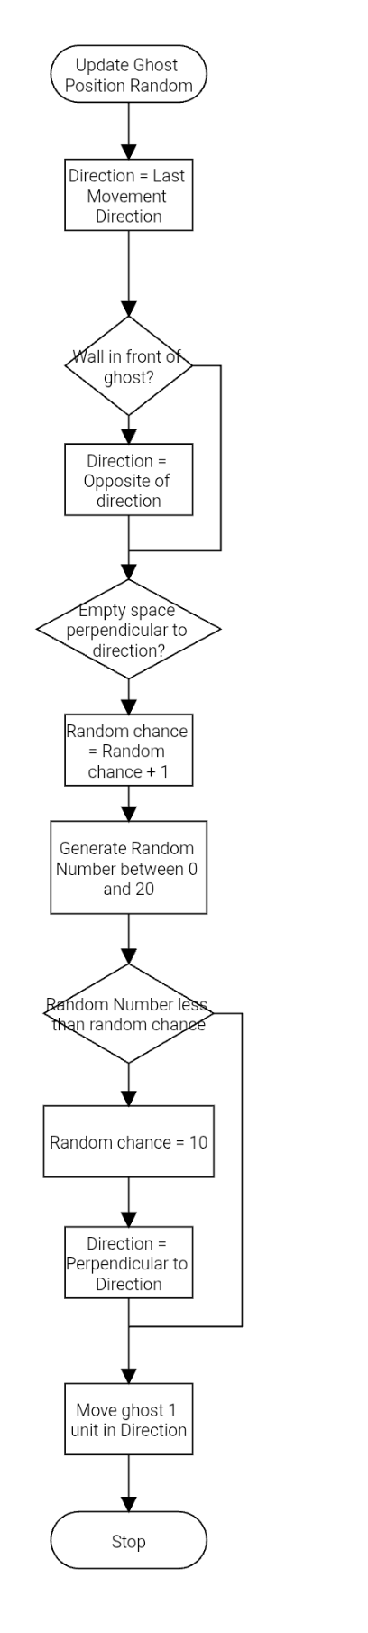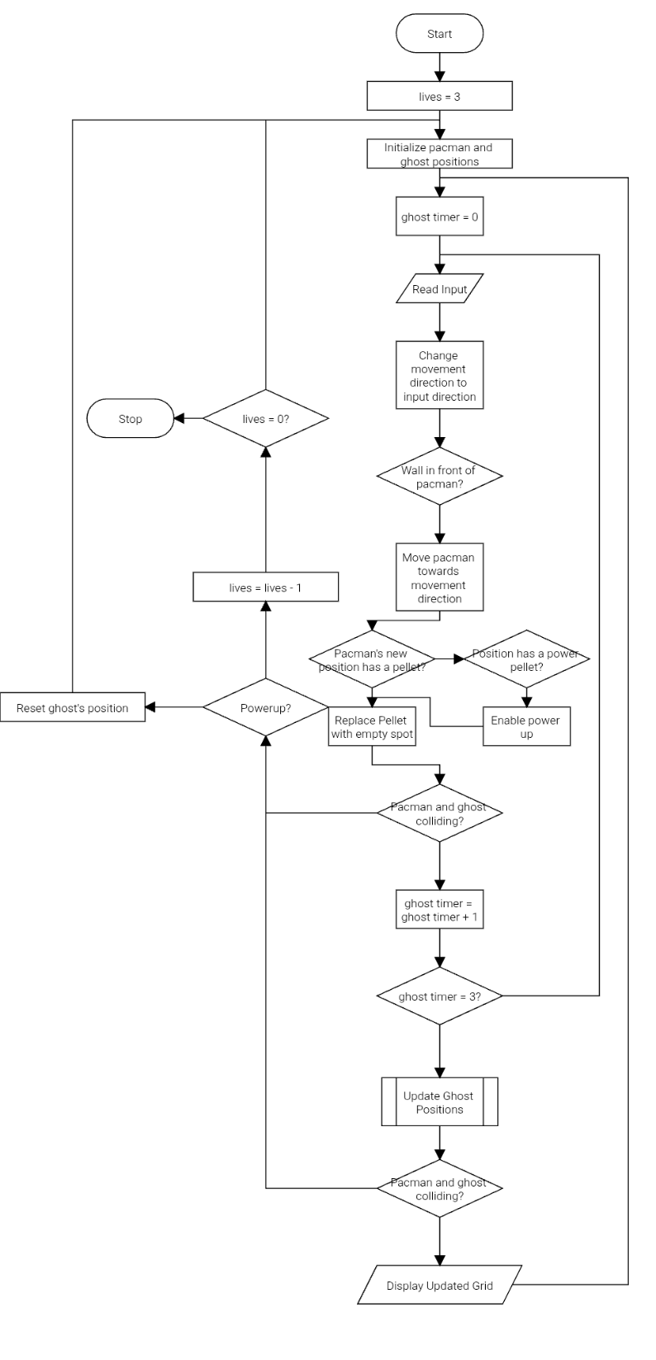
Algorithm for the random ghost ai

Implementation:
Development Environment
- Language: C
- Platform: Linux Terminal
- Libraries: stdio.h, stdlib.h, time.h, termios.h
Key Features
- Real-time input using termios
- A* pathfinding for intelligent ghost
- Teleportation mechanics
- Leaderboard stored in CSV file


Results and Discussion:
Output
- Interactive terminal-based game
- Two difficulty levels (Easy & Hard)
- Dynamic ghost movement
- Score tracking and leaderboard
Analysis
The objectives were successfully achieved. The implementation of A* improved gameplay difficulty and realism. However, performance may decrease with increased grid complexity.


Conclusion:
The Pac-Man game was successfully developed using the C programming language, demonstrating key concepts such as arrays, pointers, file handling, and real-time input processing. The use of a grid-based system allowed efficient representation of the game environment, while modular design improved code organization.
A major highlight of the project is the implementation of the A* algorithm for ghost movement, which adds intelligent behavior and makes the gameplay more challenging compared to simple random movement. Features like power-ups, teleportation, and leaderboard storage further enhance the overall functionality.
Overall, the project effectively bridges theoretical concepts with practical implementation and provides a strong understanding of system design and algorithm usage in game development.


Future Scope:
- Add graphical interface (SDL/OpenGL)
- Improve ghost AI behavior
- Add sound effects
- Multiplayer support
- Better UI/UX
- The project can be improved by adding a graphical user interface using libraries such as SDL or OpenGL to enhance visual experience. The ghost AI can be made more advanced by applying better strategies like predictive movement or multiple pathfinding techniques.
- Additional features such as multiple levels, sound effects, and difficulty scaling can make the game more engaging. The leaderboard system can also be enhanced with ranking and better data management. Expanding the project to include multiplayer functionality would further increase its complexity and real-world relevance.


Research Paper/Patent Details:


Plagiarism Check:

